Step-by-Step Analysis of Your Approach:
Step 1: Randomly select 20 examples from each class
- Analysis :
  - Random sampling ensures that you are working with a manageable subset of the data, which is useful for computational efficiency.
  - However, randomly selecting 20 examples may lead to bias if the dataset is highly imbalanced or if the selected subset does not adequately represent the overall distribution of the class.
  - If the dataset is small, randomly selecting 20 examples might not leave enough data for training and testing.
- Upgrade :
  - Instead of random sampling, consider using stratified sampling to ensure that the subset is representative of the class distribution.
  - Alternatively, use all instances in the dataset if computational resources allow. This ensures no loss of information during the calculation.

Step 2: Evaluate the mean for each class attribute
- Analysis :
  - Computing the mean for each attribute is a reasonable way to summarize the central tendency of numeric attributes for each class.
  - However, this approach assumes that the data is well-behaved (e.g., normally distributed) and ignores other important statistical properties like variance, skewness, or higher-order moments.
- Upgrade :
  - Instead of just computing the mean, consider summarizing each class using multiple statistics, such as:
    - Mean
    - Standard deviation (to capture spread)
    - Median (to handle outliers)
    - Minimum and maximum values (to understand range)
  - Alternatively, compute a centroid vector for each class by taking the mean across all attributes. The centroid vector represents the "center" of the class in the feature space.

Step 3: Take the average of all the mean scores for each class
- Analysis :
  - Averaging the mean scores across attributes provides a single scalar value for each class, which simplifies comparisons.
  - However, this step discards valuable information about individual attributes and their contributions to the similarity measure. For example, some attributes may be more important than others in determining class relationships.
- Upgrade :
  - Instead of averaging the mean scores, retain the centroid vector for each class (as suggested in Step 2). This allows you to compute similarity measures in a multidimensional feature space.
  - If you want a single scalar value, consider weighting the attributes based on their importance (e.g., using domain knowledge or feature importance scores from a machine learning model).

Step 4: Take the difference between each class in the dataset
- Analysis :
  - Taking the difference between classes is a simple way to quantify dissimilarity. However, it assumes that the absolute difference between scalar values is meaningful, which may not always be the case.
  - Differences between scalar values do not account for the relative scale of the data or the directionality of differences.
- Upgrade :
  - Use a distance metric to calculate the dissimilarity between classes. Common distance metrics include:
    - Euclidean Distance : Measures the straight-line distance between two points in the feature space
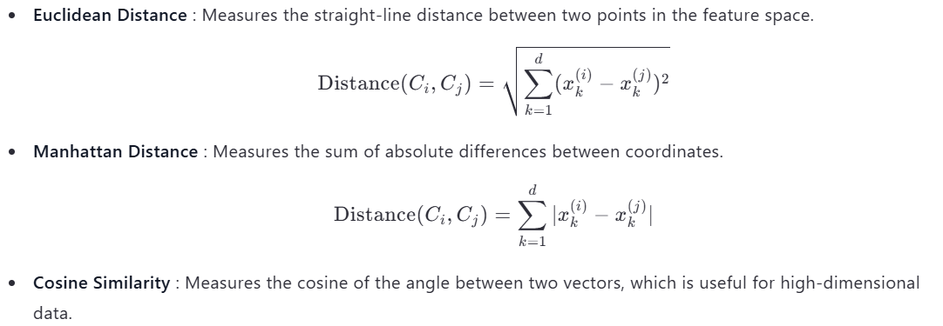
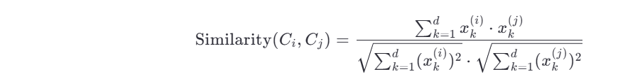

  - If you are using centroids, compute the distance between the centroids of the two classes.

Step 5: Normalize the values to derive a degree of similarity (μ)
- Analysis :
  - Normalizing the values to a range of [0, 1] ensures that the similarity scores are comparable and interpretable.
  - Multiplying or dividing by powers of 10 is an ad-hoc approach that may not produce consistent results across datasets.
- Upgrade :
  - Use a formal normalization technique, such as min-max scaling or z-score normalization , to map the similarity scores to the desired range.
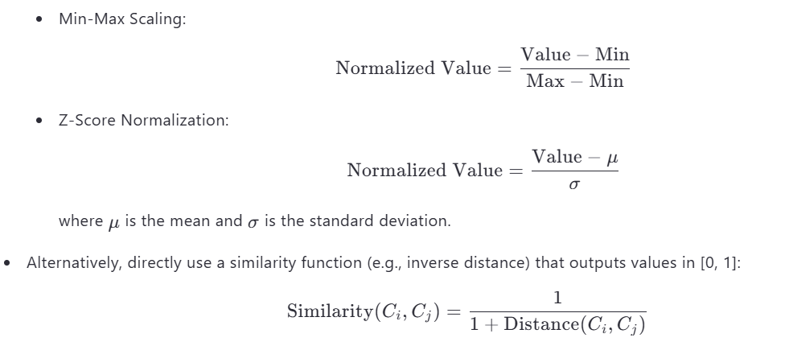
Additional Suggestions:
- Handling Categorical Attributes :
  - Your approach of converting categorical attributes (e.g., "Male" → 1, "Female" → 0) is valid, but it assumes that the categories have a natural numeric representation.
  - For nominal categorical attributes, consider using one-hot encoding or binary encoding before computing similarity.
- Weighted Similarity :
  - If certain attributes are more important than others, assign weights to them when computing similarity. For example:

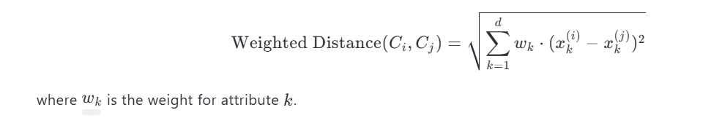
- Visualization :
  - Visualize the similarity matrix (or distance matrix) using a heatmap or dendrogram to better understand the relationships between classes.

Final Upgraded Workflow:
Here’s a refined version of your workflow incorporating the upgrades:
- Subset Selection :
  - Use stratified sampling to select a representative subset of instances from each class.
- Class Representation :
  - Compute the centroid vector for each class by averaging the values of numeric attributes.
- Similarity Calculation :
  - Compute the similarity between classes using a distance-based metric (e.g., Euclidean distance, cosine similarity).
  - Convert distances to similarities using an inverse relationship:

- Normalization :
  - Normalize the similarity scores to the range [0, 1] using min-max scaling or z-score normalization.
- Output :
  - Generate a similarity matrix where each entry μ(Ci​,Cj​) represents the degree of similarity between classes Ci​ and Cj​.
Final Answer:
Your approach is a good starting point, but it can be improved by:
- Using stratified sampling instead of random sampling.
- Representing classes as centroid vectors rather than scalar averages.
- Employing established distance metrics (e.g., Euclidean, cosine) to calculate similarity.
- Normalizing similarity scores using formal techniques like min-max scaling. By implementing these upgrades, your method will be more robust, interpretable, and aligned with best practices in machine learning.

